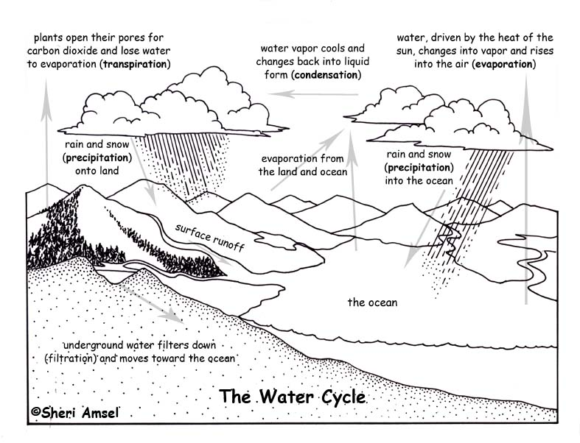
Word | Meaning
Evaporation | Heat from the _________ changes liquid _________ into a g________
Transpiration | Water e_________________ from plants through tiny p_______ on their leaves.
Precipitation | Water falls as r___________ or s_____________.
Condensation | Water v____________ cools and changes back to ________ form.
Percolation | The slow filtering of water through the soil.

State three ways that water gets into the ocean.

What is the process that forms clouds?

What do we call the type of evaporation that happens through the pores of plants?
N | E | V | A | P | O | R | A | T | I | O | N | G | N | O
T | O | N | A | E | C | O | H | Y | K | O | W | U | O | Z
P | A | I | G | R | R | L | P | N | I | Z | A | I | I | V
N | E | E | T | Y | S | D | Q | T | V | P | T | B | T | M
U | J | R | H | A | Z | C | A | Y | C | N | E | A | A | Q
Q | T | S | C | S | T | S | C | Y | D | J | R | U | R | I
R | L | O | Y | O | N | I | C | B | L | D | V | V | I | O
C | J | H | C | E | L | L | P | T | O | K | Y | Z | P | Y
I | C | Y | D | Z | E | A | N | I | T | K | P | A | S | N
X | C | N | U | S | Q | A | T | V | C | I | D | N | N | V
T | O | S | O | D | M | Y | Z | I | T | E | K | U | A | G
C | C | Q | J | R | B | I | R | A | O | S | R | S | R | L
D | D | X | P | Y | H | B | J | B | X | N | H | P | T | Q
P | N | H | I | S | Z | X | A | K | V | R | D | F | D | S
G | E | J | Y | U | B | Q | M | N | B | B | C | B | J | P

CONDENSATION | CYCLE | EVAPORATION
HEAT | OCEAN | PERCOLATION
PRECIPITATION | SUN | TRANSPIRATION

